**Digital Design (CSCE 2114) – Lab 4**

Objectives:

* Learn how to use the Mega Function Wizard to design a complex circuit. In this lab you will create an adder/sub.
* Learn how to simulate your design before implementing it on the FPGA to verify that it works.

Note: → means “Next” button

# A. Using the Mega Function Wizard for building an add/sub

1. In Quartus, create a new project (license: 1800@csce-licsrv.ddns.uark.edu).
2. Add a new *Block Diagram/Schematic File* to your project and save it with its default name.
3. Double click in the schematic window and click the MegaWizard Plug-In Manager button. →
4. Click on + next to Arithmetic and choose LPM_ADD_SUB, then specify a name for the output file (such as *Mega*). →
5. Select the *Create an ‘add_sub’ input port* option. Click Finish.
6. If a dialog box pops up, click *Yes*. Then click *OK* in the Symbol window and add the adder/sub to your schematic.
7. Connect appropriate input/output pins as pictured below. Notice that buses are named as an array, like X[7..0]. Also make sure that the pins are connected. Save the file.

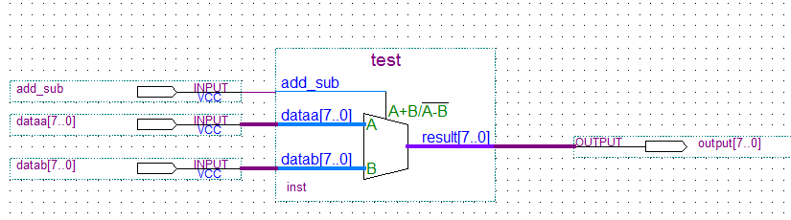

1. Click *Start Compilation* ( C:\Users\blittman\Desktop\Untitled.jpg ). You can ignore any compilation warnings, but not errors.

# B. Adding a test bench for input signals

1. Create a new *Vector Waveform File.*
2. Right click on the left panel and choose *Insert* > *Insert Node or Bus...*
3. Click *Node Finder…* and in the new window select *Pins: all* from *Filter.* Click the *List* button. Select *add_sub, dataa, datab, etc.* (hold Ctrl to multi-select). Click the > button. *OK, OK.*
4. While holding Ctrl, scroll the mouse wheel to zoom out. Now, you are able to see the whole time frame starting from 0ns to 1000ns.
5. You can choose which format you prefer to see the bus values. While holding Ctrl, select *dataa, datab, and output*, then right-click and select *Properties*. Change the Radix to Unsigned Decimal.
6. Click the Waveform Editing Tool (  ). Assign a new arbitrary waveform to *add_sub* by clicking and dragging the cursor tool across the desired time zone of the pin:



1. By clicking + next to *dataa*, you will see its bits (7 down to 0). Change four of its bits using  as seen below, then collapse *dataa* (- button).

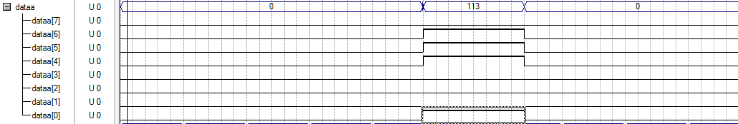

1. Right click on *datab* > *Value* > *Count Value...* In the Counting tab, change the Increment value to 2. Now select the Timing tab and change the values to:

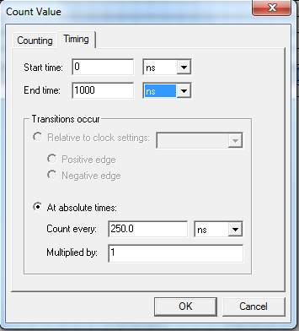

# C. Simulation results

Now it is time to see the simulation results. Save the waveform file and then click . Hopefully you will see a pop-up box saying “Simulator was successful”.

Check out the waveform for the *output* pin in the Simulation Report (you may need to zoom out: hold Ctrl and scroll). You can experiment by changing the waveform for any of the input pins and running the simulation again to see how it affects the output.

